Types of Compound Words
# Source: AI Source: Provided by: [Data Path: Persons Table -> ID Column: 1, Name_En Column: Motasem Essam] -> From: [Chatgpt (GPT-4-turbo)] on [7/25/2025]
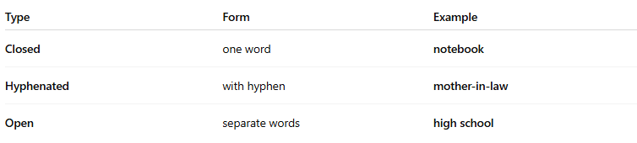

Type | Form | Example
Closed | one word | notebook
Hyphenated | with hyphen | mother-in-law
Open | separate words | high school

